Name :-Amit Rawat Course:- MCA

Section:-A ID: 20711018

Solution 1:-

class Middemo

{

public static void main(String[] args)

{

int i=5,fact=1;

for(i=5;i>=1;i--)

{

fact=fact\*i;

}

System.out.println(fact);

}

}

OUTPUT:-

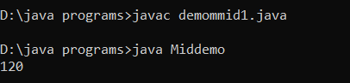

Solution 2:-

class Middemo

{

public static void main(String[] args)

{

int a=1,b=2,c=3;

System.out.println(a+b+c);

}

}

OUTPUT:-

